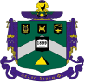
Delta Sigma Phi Alumni

SLO / CA
Alumni Newsletter
Issue #20: Summer 2019 / July

This Issue's Theme:


The Lesson Of Sphinx
........ Is Patience

In This Issue


National Fraternity President's Message (p# 2)

Epsilon Rho Alum Helps Texas Chapter Re-Start (p# 3)

Past National Officer Helps Utah Chapter Re-Start (p# 3)

The CCAB (Collegiate Chapter Advisory Board) Chapter Support Model (p# 4)

Outgoing CCAB Advisor Offers Cross-Training To New Advisor (p# 5)

ACB Meeting Report (p# 6)

Update Of ACB By-Laws (p# 8)

National Convention Is This Summer (p# 9)

Third Annual Delta Sig Alumni Debacle In The Desert (Golf) (p# 9)

An Alumni Thank-You-RF Is Concluded (p# 9)

DSP's 2019 Alumni Reunion Was A Great Success (p# 10)

Announcement - Invitation To Cystic Fibrosis Benefit Golf Event (p#11)

Our Brotherhood Needs Your Help (p# 12)


National Fraternity President's Message,
By Epsilon Rho's Jim "Lurch" Larson, W'72

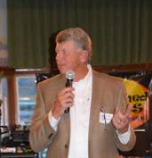
"Since I was elected president of our great Fraternity almost two years ago, your Grand Council and I have determined that there are a few things which are critical to the success and future sustainability of Delta Sigma Phi.

It is clear that membership growth is our lifeblood. Whether we are looking at the personal development of each brother, the strength of a chapter, or the relevance of the National Organization, if we do not grow we will become an after-thought on the national stage. To achieve our Vision of Becoming America’s Leading Fraternity and continue our Mission of Building Better Men, we must both add new chapters and membership, and retain our existing chapters and members. It is equally essential for us to open new chapters in the right places as it is to re-ignite closed chapters. We must also remain resolutely focused on ensuring the safety, health and well-being of our undergraduate brothers and those they interact with.

For a variety of reasons, in recent years we have closed nearly as many chapters as we have opened. We have lost nearly as many brothers as we have initiated. This is absolutely the most perplexing paradox now facing fraternities.

We live in an era of instant virtual communication, and this results in a significant reduction in face-to-face student interaction; a type of isolation. Young men are greatly benefitted when they become affiliated with a Fraternity. They enjoy the close bonds of brotherhood and mutual support that the organization provides, along with professionally-designed-and-delivered character-and-social-responsibility-enhancing programming.

While there will always be some individuals in any organization who behave in ways that almost guarantees their self-destruction, the vast majority of our undergraduate members model the values and principles of Delta Sigma Phi: Culture, Harmony, Friendship. We as a Grand Council will continue our efforts to educate, develop, and instill the attributes that build better men. It is our hope that this will make the world ever more convinced of the sincerity of our purpose.

We are only able to accomplish our mission through the support and commitment of hundreds of volunteers who also believe in our objectives - and who donate hundreds of hours of their time and a great deal of their treasure. They do this to help us perpetuate what our Fraternity can do for young men - now and in the future, and the positive impact this has on our communities and country. If you’re one of these men who contribute, I can’t thank you enough! If you have not yet given back, I ask you brother-to-brother to please join the fight and pay-the-debt."

Epsilon Rho Alum Helps Texas Chapter Re-Start

F'72 Wayne "Dizzy" Kendrick writes us about assisting DSP's Theta Eta Chapter to restart and successfully operate in Texas.

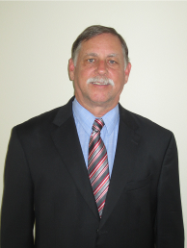
"Theta Eta Chapter at Texas State University was installed in February 1994 but was short-lived and closed in 1997. In November 2015, I met with National staff who came to Texas State to begin the process of restarting Theta Eta. Meetings with campus staff, students, and area alumni were held. This is when the discussion started regarding establishing our Collegiate Chapter Advisory Board (CCAB). I accepted the opportunity to be an advisor for the New Chapter.

Beginning Spring Semester in January 2016, the National recruiters arrived to begin the preparation stages of starting the six-week recruitment effort at Texas State. Part of the process was learning about San Marcos and the surrounding community. I was a local resource and participated through the Founding Father Ceremonies (Pinning Ceremonies) which were completed in March 2016. Then the New Member Class came together to begin their journey as Delta Sigs. At this point, the recruiters left and another staff member arrived to help guide the Executive Board toward becoming a Chapter. With their hard work, Theta Eta was chartered in October 2017.

Re-chartering moved fast for us and there isn't yet an ACB. We adapted National's suggested CCAB structure to meet our needs. In my position as one of three Chapter Advisors, I work with and provide guidance to the Chapter Treasurer, Executive Board members and other advisors. I assist with processes for budget planning, a calendar of activities with expenses, fixed expense requirements, managing bank accounts, etc.

My efforts have been an enjoyable experience, yet at times very challenging. I've worked with four treasurers and four Exec Boards, as new officers start every Spring Semester. The results are very encouraging as we watch the growth and improvements of the Chapter as it is led by outstanding undergraduate leadership teams."


Past National Officer Helps Utah Chapter Re-Start

(Editor's Note: Mike Wims, current Chapter Advisor for DSP's Iota Kappa Chapter at the University of Utah in Salt Lake City, writes about their 2012-2013 restart experience. Mike is a retired Air Force JAG Colonel who was initiated at the Gamma Xi Chapter at the University of North Texas. He has served twice as a DSP District Governor, and was a Fraternity Grand Council officer for over three decades. Prior to restarting Iota Kappa, he helped restart the Eta Chapter at the University of Texas and the Theta Kappa Chapter at the University of Alabama. Not well known by many alumni, Mike has extensively assisted Epsilon Rho prior to, during, and since our disaffiliation. Most recently, he helped us by providing expert guidance with our by-laws update process.)

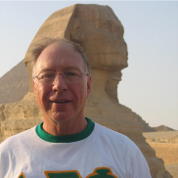
Mike tells us the University of Utah Colony was first started in 1992 and failed. "We didn't have folks around to help the colony get off the ground in '92." After closure, Mike invested in building the Northern Utah Alumni Association to help support the restart when that time came.

"When considering an expansion of fraternities, it is common for IFC's to invite national fraternities to submit an application. The top applicants are then invited to come and submit a presentation." In 2012 DSP was selected to make a presentation.

In IK's presentation, "the Deputy Executive Director and 8-to-10 alumni from several chapters made the presentation to IFC and their campus administrator. The strong presentation included a focus on the significant amount of funds set aside, and professional staff, and money for education of the young men. The presentation also stressed providing leadership training, an already built-in alumni support group, and assistance from another nearby chapter at Utah State."

Mike asked that the following be underscored to our EP alumni: "We (IK) were not alone, and you will not be alone. When EP first comes back on campus, we will not be a chapter (managed) operation, but a national (managed) operation. National has staff specifically skilled for expansion, and this is all they do."

Mike added, "The pros teach the recruits about meetings, recruitment, bank accounts, etc., etc. The recruitment and training team is not subcontracted; they are on staff, because they have to do the first initiation, so they must be Delta Sigs."

Editor's note: Our National Fraternity emphasizes that the greatest predictor of a newly started chapter's success is extensive alumni engagement. This is critical to provide ongoing instruction in areas such as organizational performance and personal conduct expectations, and to provide mature oversight, member-training, and direct coaching.

The CCAB (Collegiate Chapter Advisory Board) Chapter Support Model, by Yabut

Our National Fraternity has developed the CCAB organization to provide undergraduate chapter oversight and guidance. Volunteer advisors guide undergraduate chapters and members in day-to-day chapter operations. The CCAB's focus is on internal chapter operations while the ACB handles external operations such as housing, etc. An undergraduate chapter may have both a CCAB and an ACB. One of the additional goals of the CCAB is to distribute among others the significant workload that otherwise falls on the Lead Chapter Advisor.
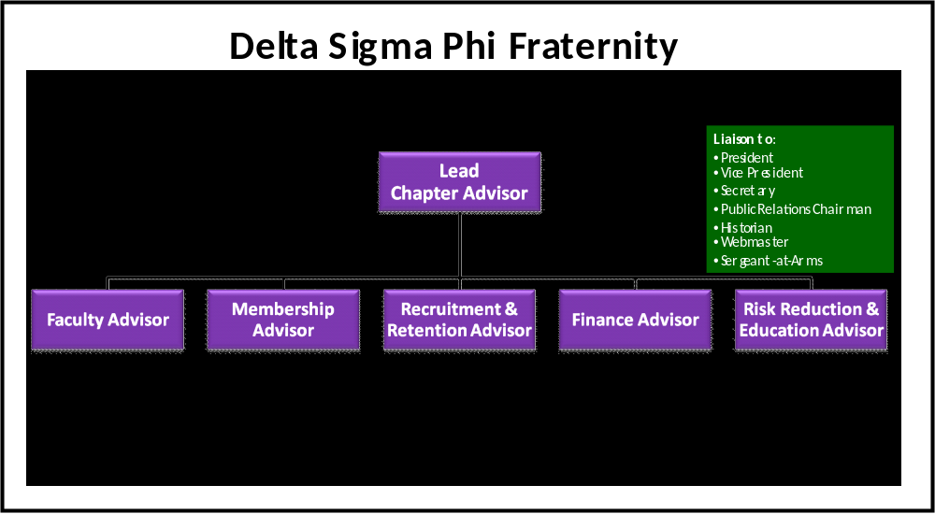

Brothers, please ask yourself this question. If you were a National Fraternity deciding on which chapter to restart, or a University considering which Fraternity to recognize, wouldn't a well-staffed-and-trained CCAB Board be a significant factor in your assessment? We need to staff and train this additional Board prior to National's petition to the University, whenever that occurs. If your answer is "yes" and you want more information, Yabut can help with who to contact: 530-941-3986 / cpatterson76@outlook.com.

Outgoing CCAB Advisor Offers Cross-Training To New Advisor

After nearly ten years on the CCAB, your Editor has stepped-aside as an Advisor and offers to train the next alum appointed by the ACB to fill the Recruitment and Retention Advisor position. In March Yabut wrote ACB:

"It has been my great pleasure to serve Epsilon Rho for almost ten years as its Collegiate Chapter Advisory Board (CCAB) Recruitment and Retention Advisor. However it is time for me to step aside for a younger brother to serve in this critical role.

I feel I can best serve EP and our Fraternity by focusing on my other volunteer duties. These responsibilities include AA's goal to find, inform, and connect alumni, and encourage their engagement, by providing newsletters, E-News, web site, and reunion planning. I will also have more time to continue our philanthropic Poly P Scholarship program which provides alumni a collective means to give-back to our alma mater in a manner that brings credit to Delta Sigma Phi.
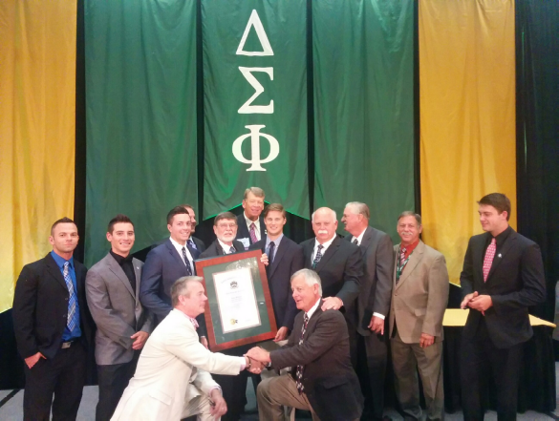
By resigning from my CCAB position now, we have time to recruit to this vital volunteer position and provide training and support for the new Advisor. I look forward to transferring recruitment tools we've developed to the new Advisor and offering my full support. Our CCAB Advisor positions present alumni an opportunity to become engaged and are an important potential step in successor-leadership development!

I am particularly proud of the successes the alumni-undergraduate recruitment team achieved prior to campus disaffiliation - from 2013-2015. As this photo shows, this resulted in the chapter receiving the Fraternity's first-place award for recruitment at the 2015 National Convention!" YITBOS, Yabut

ACB Meeting Report

Our April 13, 2019, ACB meeting was well-attended. It focused on ACB-responses to conduct issues of DSP undergraduate members of our closed chapter, Board elections, and setting a financial savings goal for future surplus funds.

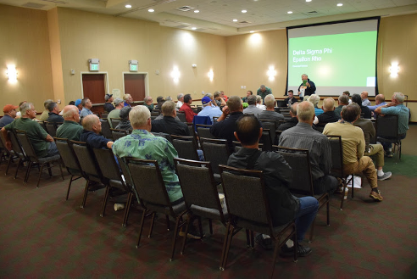

Major Discussion Item
Board President Jonathan Peabody Monfort, F'81, made a detailed presentation of feedback from the University and IFC regarding their complaints. At issue was a University/IFC assertion that our remaining undergraduate members of our closed chapter had not ceased all organized DSP fraternal operations as required by National Fraternity, ACB, Alumni, and the University.

To provide context, our chapter was officially closed by National Fraternity and our charter was revoked on April 1, 2018. This was part of an 18-month sanction period imposed by the University as a condition to re-open discussions of a probationary return program of the University's design. National and the University share many of the same student-development goals, such as academic achievement, social responsibility, bystander accountability, campus and community service, and student health and safety. While our National Fraternity continues to do all it can in support of chapter return, and is hopeful of chapter reinstatement at the earliest opportunity, it cannot predict this date.

The sanction was due to a drug-related risk-management issue in 2014 that severely distressed our Alumni, Board, Fraternity, and alma mater. This sanction was not associated with the members at the time of closure, as they had joined subsequent to 2014.

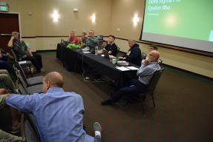
In compliance with the National Fraternity and University directive, all Fraternal programming and operations ceased on the aforementioned date. Members were specifically instructed they would remain brothers, that their conduct would reflect on DSP, but that they could not in any way represent or conduct themselves as a Delta Sigma Phi organization. To emphasize closure and compliance to the undergraduates, all Fraternal memorabilia was removed from the former chapter facility in May 2018 and placed in secure, off-site, commercial storage.

Our National Executive Director has held phone conferences with ACB, issued two warning letters to the undergraduates, and he and our ACB President have worked with University officials in good faith to address this issue. In March 2019, our National Fraternity reclassified these undergraduate brothers from "undergraduate alumni" to undergraduates-on-suspension, and other action is under consideration. Their Fraternal suspended status continues through graduation or other separation from the University. Our Executive Director has informed the University that should any undergraduate members remain enrolled at the time of chapter re-recognition, they cannot participate in the development or operation of the new chapter.

Passed Motion
According to our ACB President: "The motion was to set aside 75% of rental revenue to a separate account building fund. We need to secure a focused building fund in order to afford a self-sufficient and growing account that can only be used for the purpose of rehabilitating, maintaining, and rebuilding of the chapter facility."
Chapter Facility Rented To Sorority
Beginning August 1, 2019, our chapter facility is rented to a sorority for a period of two years, and they have an option to extend the lease one additional year. These rental funds will assist ACB in rebuilding its finances.

(Editor's Note: This does not prevent our National and alma mater from reaching an agreement to restart the chapter during this lease period. We're told that National does not allow members of new chapters to live together in a DSP chapter facility for the first one-to-two-years. This is done for risk-management purposes. During this period new members receive significant training regarding their responsibilities to DSP, the University, the student body, and the community. They must pass several hurdles, including being required to develop and demonstrate responsible self-governance prior to receiving National Fraternity permission to occupy a chapter house.)

Board Member Recognition
National President Larson presented retiring Board Member Rick Rengel a national recognition award for his years of service.

ACB Election
With the exception of Brother Noel "Bull" Shutt, F'69, a new Board member elected to the position of Chapter Advisor, and Bill FUBAR Bradley, F'63, who moved from Chapter Advisor to the vacated VP/Housing position, four other incumbent officers were re-elected to their respective positions and the AA President, who also serves on the Board, continues in that role. Elections are held in odd-numbered years and there are seven alumni officers.

Update Of ACB By-Laws
By Yabut

In late 2018, ACB authorized the creation of an Epsilon Rho By-Laws Committee to review and bring our antiquated by-laws up-to-date, and in compliance with National Fraternity requirements. Our By-Laws had been patched for many decades, without full document review, which resulted in many internal procedural conflicts. The passage of decades without a comparison of EP's By-Laws to the evolving requirements and recommendations of National resulted in some EP provisions being out-of-step with National. Updated ACB By-Laws are one of many requirements for the reconstitution of a closed chapter.

Committee members were selected based upon their business experience, judgment, and engagement with Delta Sigma Phi. Committee members came from five of our seven decades: the 1950's, 1960's, 1970's, 1980's and 2010's. Three of the committee members are ACB officers: W'64 recent Chapter Advisor and now ACB VP Bill FUBAR Bradley, F'69 current ACB Chapter Advisor Noel Bull Shutt, and S'13 ACB Secretary Eric Goat Winkler. The committee's other eight members are: Jim 3.2% Evans, S'58; Jim Ozzie Nelson, F'71; Wayne Dizzy Kendrick, F'72; committee chair Chris Yabut Patterson, W'73; Jim Limpet Bickel, F'80; Rich TD Jacobsen, F'82; Jon Bonzo Schull, F'82; and Colonel Doug Frank Paul, F'87. National's Parliamentarian, Stan Hill, was a tremendous help in providing us guidance, and we extend our thanks to him. The committee presented its updated By-Laws to ACB on June 20th for their consideration.
National Convention Is This Summer

Our National Convention is August 1-4, 2019, in Kansas City, MO. Several alumni are attending and many are taking their wives because the Convention offers a great program of non-fraternal fun-filled activities for the ladies! Brother Noel Bull Shutt will represent ACB as a voting delegate and Brother Chris Yabut Patterson will represent AA as a voting delegate. Epsilon Rho's Jim Lurch Larson, W'72, National Fraternity President, encourages you to contact him for more information! Give him a call at 847-309-0596 or email him at jwlarson2@hotmail.com!


Third Annual Delta Sig Alumni Debacle In The Desert (Golf)
By Noel "Bull" Shutt, F'69

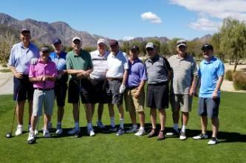
"Here it is! A group photo of the Debauchers at the 3rd Annual Debacle-in-the-Desert!

I believe you can identify them all. First place was W'73 Woody; second place was a tie between W'72 TA and W'72 Lurch - thus no third place!"

YITBOS
Bull

An Alumni Thank-You-RF Is Concluded

To say thanks for years of Delta Sig work, S'71 Mike "Snidley" Ivy "snuck" Yabut's '68 Mustang convertible from his locked garage - so brothers could fix its failing transmission. Clearly this was an inside job! What began as a "tranny-job" escalated into many major repairs to make the car reliable for wife Carol to drive! In the end, twenty brothers "ponied-up" for this generous gift. On March 13th this year Snidely wrote:

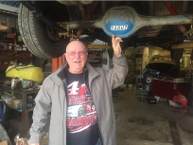
"Brothers:
I've had Yabut's Mustang for over a year now. I feels it's time to let the RF go and return the car to him. We're going to find a restaurant to do this. Hope some of you can get together and car pool. I will send out more info as I know where we're going to meet. I've cc Yabut on this email as he has not known who supported me on this wonderful RF project. To make sure everything was in good shape. I drove it from Modesto to Poly Royal last year (and made it)! Thanks for all your help and support. Please come to the returning of the Mustang if you can!"

YITBOS, Snidley

Brothers, this is Yabut. Thanks Snidley, Woody, Gunga, Ichabod, TA, Pele, Ortho, Lurch, Dizzy, Si'mon, Penny, Cleat, Harpo, Rollo, Bull, Ozzie, HOTS, Deuce, Rocky, and Grobo! Thanks men, I'm truly honored. You can come by anytime for a ride - as long as you drive! YITBOS!

DSP's 2019 Alumni Reunion Was A Great Success
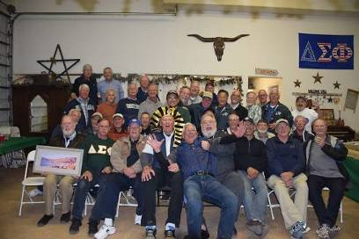
Alumni BBQ: The Thursday, April 11th, BBQ at TA and Donna's home in Nipomo set an attendance record! Their son Trevor, shown in the photo below, did a wonderful job.

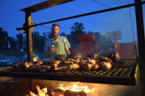

Alumni Charity Golf Tournament

On Friday, April 12th, thirty-six alumni participated in DSP's Charity Golf Tournament. This year the tournament raised $3,450 for future member scholarships once our chapter is re-established. The funds were sent to Delta Sigma Phi's Foundation and deposited into the 21st Century Fund account for management until the chapter can be restarted.

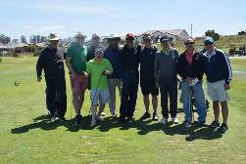
1st Place Honors: Jim “Limpet” Bickel (F80), Tony “Beav” Rodriguez (S82), and
Chuck “Buckwheat” Waltman (S82).

Second Place Honors: Jeff “Putter” Clark (F84), Jeff “Skeeter” Rogers (F83), Jon “Cap” Krause (S82), and David “Ook” Woodward (F86).

Third Place Honors: Allen “Haso” Tom (S69), Arlene (Haso Significant Other), and Jess “Limp” Lee (S69).

Alumni Dinner-Dance

On Saturday, April 13th, 93 attended the alumni dinner-dance at Madonna Inn. This event raises funds for Delta Sigma Phi's Poly P Scholarship for non-Greek first-year men and women students. Since the philanthropic scholarship's founding in 2012, DSP has given $16,000 to deserving men and women based upon merit and need. This year's dinner raised $2,500 for next Fall's scholarships. The scholarship's name honors our Delta Sig brothers who built the present "P" in 1957 while providing alumni with a collective means to give back to the University.
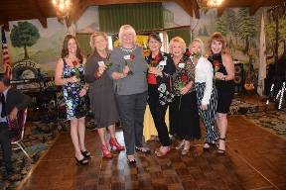

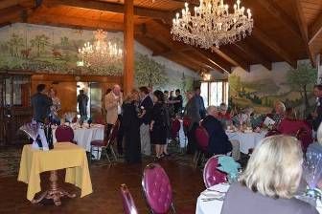
Past Dream Girls

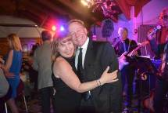
You can help this worthy cause by becoming
a Poly P Patron with a donation of only $100.

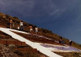
Contact Yabut and Carol for details at cpatterson76@outlook.com. Check
out www.PolyPScholarship.com!

S'80 Custer and Gigi

Save-The-Date For Next Year's Reunion: April 23-25, 2020

Our 2020 Alumni Reunion is Thursday through Saturday, April 23-25! This is two weeks after the University's Open House (Poly Royal) and one week after Easter. We will again have an alumni BBQ, golf tournament, tournament dinner open to everyone, ACB meeting, and dinner-dance with silent auction. Next year's dinner-dance will again be at Madonna Inn and feature the great band "Unfinished Business" (check them out on-line). By alumni request, we are adding an hour to the evening's schedule and the band's play-time! Let's develop a reunion theme for next year - contact Yabut with your suggestions / cpatterson76@outlook.com.

Announcement

S'70 Mike Harpo Roanhaus invites alumni to the 2019 Cystic Fibrosis Charity Golf Tournament in Santa Cruz on August 12th. Contact him at 650-465-5930 / mike.roanhaus@gmail.com


Our Brotherhood Needs Your Help

The chapter house we built in '71, Our treasured fraternal memorabilia,
now leased to a fine sorority, secure in SLO commercial storage,
will patiently wait for our return. will patiently wait for our return.

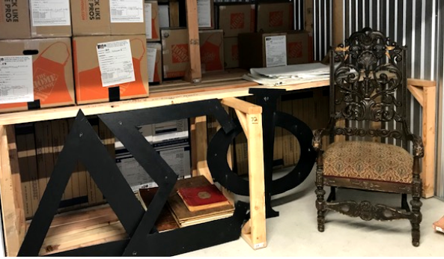
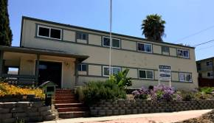


And our special bond-of-brotherhood remains!

Until the chapter can be restarted, we are the Pyramid.

Bridging the gap, preparing for restart, promoting our Brotherhood principles, supporting our Fraternity, and partnering with the University in shared student- development goals is our mission.

With Chapter closure, our Alumni Assn. has many additional responsibilities to pay for - and goals to achieve. We pay for alumni web site, and we have doubled the number of newsletters to four a year to keep you in-the-loop. Last year we also paid $2,800 for our move, $3,800 for 244's property taxes, and $2,000 for a partial-year of storage. We're also working to develop a chapter-return-assistance fund.

We strongly believe the larger our Association membership headcount - the greater our influence will be in promoting chapter reconstitution. Last year 195 of you joined - thank you! Our goal this year is 244! We need every one of you who joined last year to rejoin, and then another 49 brothers! Please - ask a PB to join with you.

Annual dues are $20. It takes 125 men at $20 each JUST to pay for annual storage. If you can, please add a donation to help build our chapter-support fund.

How To Give By Check: Please make your check payable to DSP EP Alumni Assn. and mail it to Ray Calande (“Mumbles”, W’74) at 1384 Rue Avati, San Jose, CA 95131-2547

How To Give Electronically: Go to PayPal.com, follow instructions, and give to: dsp_at_calpoly@att.net.

